Geometry: Prove It!
An Interactive Common Core Geometry WebQuest
__________________________________________________________________
Introduction:
In this WebQuest designed for a Common Core Geometry class, students will visit several websites and other online sources to learn, answer questions, and fill in charts about geometry proofs. Throughout the WebQuest, students will gather information that will help them complete geometric proofs and will eventually complete proofs on their own.

Objectives:
Following the completion of this WebQuest, students will be able to:
- Use a two-column proof utilizing statements and reasons to put together a geometric proof,
- Use and identify triangle congruences in figures given in proof problems,
- Use properties of similar figures to complete proofs, and
- Use the phrase “corresponding parts of congruent triangles are congruent” in a proof.

Materials:
The required materials for this WebQuest are the student packet given by the instructor, a pencil, and a computer, tablet, or other device that has Internet access so that students are able to go to the given websites on the WebQuest.

New York State Common Core and Next Generation Standards Used:
- CCLS – Math: G.CO.9: Prove theorems about lines and angles. Theorems include: vertical angles are congruent; when a transversal crosses parallel lines, alternate interior angles are congruent and corresponding angles are congruent; points on a perpendicular bisector of a line segment are exactly those equidistant from the segment’s endpoints.
- CCLS – Math: G.CO.10: Prove theorems about triangles. Theorems include: measures of interior angles of a triangle sum to 180°; base angles of isosceles triangles are congruent; the segment joining midpoints of two sides of a triangle is parallel to the third side and half the length; the medians of a triangle meet at a point.
- NextGen – Math: GEO-G.CO.9: Prove and apply theorems about lines and angles.
- NextGen – Math: GEO-G.CO.10: Prove and apply theorems about triangles.
- NextGen – Math: GEO.G.CO.11: Prove and apply theorems about parallelograms.

Instructional Protocol:
At the beginning of this activity, students will be given a packet and the instructor will briefly go over the outline of the WebQuest before letting students work on completing the WebQuest independently or in groups. The students will visit the sites in the WebQuest via a QR scanner, or a clickable link, for those who don’t have access to a QR scanner. While the students are completing the WebQuest, the teacher can provide answers to any questions the students may have.

Name________________________________ Regents Geometry
Date________________________
Geometry: Prove It! WebQuest
Have you ever had a discussion with your friends or family where you bring up a point, and the people you’re with don’t believe you? Then, they hit you with the two words you don’t like hearing...the two words that change a simple conversation into a fight to express your opinion:
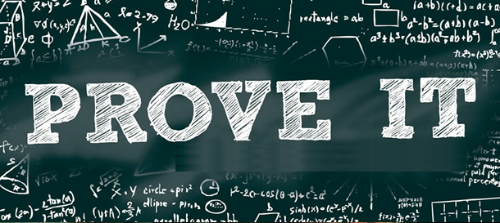
If you want people to believe what you’re saying, you have no choice but to do exactly that: prove it. That goes the same in math...you can’t just say something and expect everyone to believe you.

First, let’s learn a little bit about the structure of proofs.
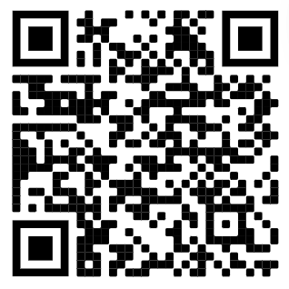
Click this link or scan the QR code and let’s start to learn about the basic structure of a geometry proof:

https://calcworkshop.com/reasoning-proof/two-column-proof/

What is a two-column proof?

What does the first column represent?

What does the second column list?

What do you always start with in a two-column proof?

What will always be in the last line of your proof?

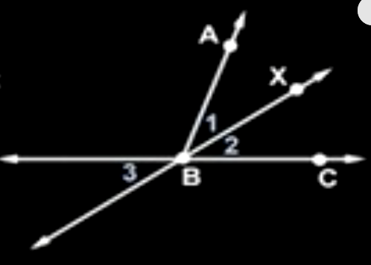

Click this next link to a video or scan the QR code and let’s see an example of a geometry proof:

https://youtu.be/zQ6Y0fismDg

In the diagram given, it’s not quite obvious that the ray $BX$ bisects the angle $∠ABC$, so fill in the following T-chart proof along with the video.
Statements | Reasons
Recall that similar triangles share certain properties, and proving triangles are similar is common in two-column proofs. Click the link or scan the QR code to the YouTube video and fill in the information below

https://youtu.be/Tlq9amS9hy4

Similarity statements help us _____________________________________________________.

Similar Triangles Property #1:_____________________________________________________.

Similar Triangles Property #2:_____________________________________________________

_____________________________________________________________________________.

When two triangles have _______________________ of congruent angles, _________________

_____________________________________________________________________________.

With this information, we’re ready to start some more practice.
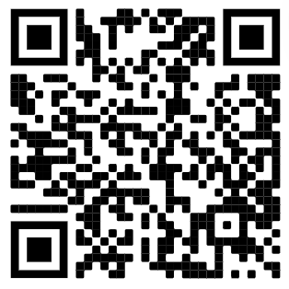
Click this link or scan the QR code to visit the next website:
http://www.mathguide.com/lessons/GeometryProofs.html

Fill in the table below with the different types of triangle congruences:
Congruence | Explanation | Diagram

What does CPCTC stand for? Fill in below:
C
P
C
T
C

After knowing what a two-column proof is and what we need to know in order to do them, go to this link or scan the QR code to go to the next stop in our WebQuest:
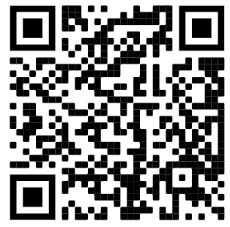

http://www.mathguide.com/cgi-bin/quizmasters/GeoProof.cgi

Take the initial ‘quiz’ on the website and take as many tries as you need until you get the proof right. Each time, jot down the mistakes you made below so you can reinforce your knowledge of the different reasons used in two-column proofs. After you get the first quiz correct, click “Next Problem” and practice with a few more problems.

What are some mistakes you made in the practice problems?

1.

2.

3.

4.

5.

Now you’re ready to take on geometry two-column proofs on the Regents exam!

Name_____Key/Scoring Rubric_______________ Regents Geometry
Date________________________
Geometry: Prove It! WebQuest
Have you ever had a discussion with your friends or family where you bring up a point, and the people you’re with don’t believe you? Then, they hit you with the two words you don’t like hearing...the two words that change a simple conversation into a fight to express your opinion:
If you want people to believe what you’re saying, you have no choice but to do exactly that: prove it. That goes the same in math...you can’t just say something and expect everyone to believe you.

First, let’s learn a little bit about the structure of proofs.
Click this link or scan the QR code to visit the next website: https://calcworkshop.com/reasoning-proof/two-column-proof/

What is a two-column proof?
A proof is a logical argument that is presented in an organized matter.

What does the first column represent?
It represents our statements or conclusions; it represents our “if-then” statements.

What does the second column list?
It lists our reasons; it explains why we know what we know.

What do you always start with in a two-column proof?
You always start with the information you are given.
What will always be in the last line of your proof?
The last line will always be whatever you are asked to prove or show.

Click this next link to a video or scan the QR code and let’s see an example of a geometry proof
:

https://youtu.be/zQ6Y0fismDg

In the diagram given, it’s not quite obvious that the ray BX bisects the angle <ABC, so fill in the following T-chart proof along with the video.

Statements | Reasons
1. Ray $\vec{BX}$ bisects $∠ABC$  2. $∠1$ is congruent to $∠2$  3. $∠2$ is congruent to $∠3$  4. $∠1$ is congruent to $∠3$ | 1. Given  2. Definition of an angle bisector  3. Vertical angles are congruent  4. Transitive (or substitution) property

Recall that similar triangles share certain properties, and proving triangles are similar is common in two-column proofs. Click the link or scan the QR code to the YouTube video and fill in the information below

https://youtu.be/Tlq9amS9hy4

Similarity statements help us __________ determine which angles and sides correspond_______.

Similar Triangles Property #1:______ Corresponding angles are congruent_____________.

Similar Triangles Property #2:____ Corresponding sides have ratios that are_______________

_______ equal to ratios formed by other corresponding sides__________________________.

When two triangles have _____two pairs____ of congruent angles, _____the third________

_________________pair also has to be congruent________________________________.

With this information, we’re ready to start some more practice.
Click this link or scan the QR code to visit the next website:
http://www.mathguide.com/lessons/GeometryProofs.html

Fill in the table below of the different types of triangle congruences:
Congruence | Explanation | Diagram
SSS | When two triangles have three corresponding sets of sides congruent, use SSS to say the triangles are congruent. | 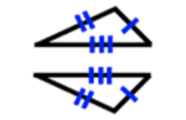
SAS | When two triangles have two pairs of sides congruent and the angles between them are congruent, use SAS to say the triangles are congruent. | 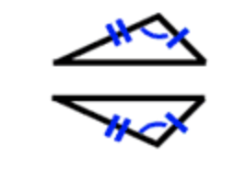
ASA | When two triangles have two pairs of angles congruent and the sides between them are congruent, use ASA to say the triangles are congruent. | 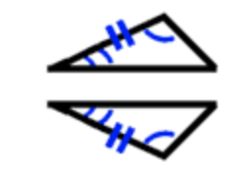
AAS | When two triangles have two pairs of angles congruent and the sides not between them are congruent, use AAS to say the triangles are congruent. | 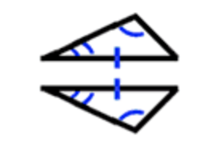
HL | When two right triangles have congruent hypotenuses and a pair of congruent legs, use HL to say the triangles are congruent. | 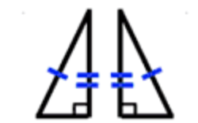

What does CPCTC stand for? Fill in below:
C – Corresponding
P – Parts of
C – Congruent
T – Triangles are
C – Congruent

After knowing what a two-column proof is and what we need to know in order to do them, go to this link or scan the QR code to go to the next stop in our WebQuest:

http://www.mathguide.com/cgi-bin/quizmasters/GeoProof.cgi

Take the initial ‘quiz’ on the website and take as many tries as you need until you get the proof right. Each time, jot down the mistakes you made below so you can reinforce your knowledge of the different reasons used in two-column proofs. After you get the first quiz correct, click “Next Problem” and practice with a few more problems.

What are some mistakes you made in the practice problems?

Student answers will vary, but sample answers may include:

- I confused the reasons “Definition of a right angle” and “Definition of a perpendicular.”

- I used the “Substitution property” in the incorrect part of the problem.

- I misplaced the “Substitution property” with the “Definition of complementary” in my proof.

- I misremembered the definition of an angle bisector.

- I confused complementary angles with supplementary angles.

Now you’re ready to take on geometry two-column proofs on the Regents exam!

Geometry: Prove It! WebQuest Scoring Rubric

 | Zero (0) Points | One (1) Point | Two (2) Points
Section 1:  QR Code/Link 1 | The student fails to fill in the chart regarding the first QR code/link. The chart is left blank. | The student puts in some information for the chart but leaves some parts out or leaves out essential information. | The student completes the given chart to completion, filling in all necessary information.
Section 2:  QR Code/Link 2 | The student fails to answer the questions given regarding the second QR code/link. The questions are left blank. | The student puts some information in, but answers the questions incompletely, or leaves out essential information. | The student answers all questions to completion and includes all necessary information.
Section 3:  QR Code/Link 3 | The student fails to answer the questions given regarding the third QR code/link. The questions are left blank. | The student puts some information in, but answers the questions incompletely, or leaves out essential information. | The student fills all blanks to completion and includes all necessary information.
Section 4:  QR Code/Link 4 | The student fails to fill in the chart regarding the fourth QR code/link. The chart is left blank. | The student puts in some information for the chart but leaves some parts out or leaves out essential information/pictures. | The student completes the given chart to completion, filling in all necessary information and pictures.
Section 5:  QR Code/Link 5 | The student fails to complete the quizzes assigned using the fifth QR code/link. The student shows no understanding of geometric proofs and leaves the “mistakes” section blank. | The student shows some understanding of the practice problems and lists a few mistakes they made regarding the problems. The mistakes they made lack validity, or don’t make sense. | The student gives valid and understandable reasons for mistakes they made using the practice problems given in the WebQuest and understands why their mistakes were made.

Final Grade _______ / 10 (score can be scaled to instructor’s preferred weight)

