NCCTM MINI-GRANT PROPOSALS

The North Carolina Council of Teachers of Mathematics through its mini-grant program, provides incentive funding for North Carolina teachers as they develop activities to enhance mathematics education. This program will provide funds for special projects and research, which will enhance the teaching, learning, and enjoyment of mathematics. There is no preconceived criterion for projects except that students should receive an on-going benefit from the grant.

Available to current members of NCCTM, the mini-grants are awarded by each of the three regional organizations to members within their geographic boundaries (If you incorrectly identify with the wrong region, your proposal will be ineligible for funding).

A total of $12,000 is available this year for the state’s mini-grants, with each region awarding approximately $4,000 in grants to its members. In recent years, approximately 20-25 proposals have been partially or fully funded, for an average grant of just over $850.

Directions
Please read all directions carefully and fill out the application and cover sheet completely. Failure to correctly list the NCCTM region and membership number will cause your application to not be considered. Be sure that your NCCTM membership is active for the current school year! Be sure that it is an NCCTM membership and not NCTM or some other organization. Each year we have applications that can not be considered because of the membership requirement.

- In order to ensure blind screening of your proposal, do not mention your name or the name of your school or institution in your proposal. The cover sheet will be removed after a code number has been assigned to your proposal.
- Proposals should be limited to two pages in length, 1 additional page allowed for budget, THREE PAGES MAXIMUM
- Cover sheets must be emailed as a pdf and must include principal signature and the income tax notice. Proposals must be emailed as a Word document or shared as a googledoc on or before 11:59 pm September 30 or January 15 if a second round of minigrants is possible.
- All applicants must be active members of NCCTM by September 1 for the school year in which their proposals are funded or January 1 if a second round of minigrants is possible.
- Only one application per member, per year, will be accepted.
- Effective 10.26.16, applicants must be full members of NCCTM to apply for a minigrant.
- Grant recipients will be notified as soon as possible following review of the applications.

Deadline
Grant proposals must be emailed on or before September 30 or January 15 if a second round of minigrants is possible. If proposals or coversheets are not submitted according to the provided instructions and are returned with requests for revisions, those revisions must be resubmitted by the deadline to guarantee your proposal will be eligible for review by regional committees.
Email: jmccormick@rock.k12.nc.us

You will receive an email confirmation of receipt once your proposal has been received. If you do not receive a confirmation within one week, it is your responsibility to follow-up with the Mini-grant Coordinator. Email: jmccormick@rock.k12.nc.us

Income Tax Notice
Please be aware that NCCTM is required to report all grants of $600 or more to the Internal Revenue Service. In such a case you will receive an IRS Form 1099-MISC from NCCTM. NCCTM has been advised that if you receive one of the NCCTM grants, you must include the grant proceeds in income.
MINI-GRANT DESCRIPTION GUIDELINES

For your project proposal to receive favorable consideration, the guidelines below should be followed. Use section one (I) as an outline for your proposal, being certain to incorporate the points in section two (II) - The proposal should be typed or printed clearly in black ink to facilitate reproduction for judging-

I. Projects will be evaluated on the following criteria:
A. Purpose/objectives
B. Justification (why project is important) - Include a description of how the proposal addresses content and practice standards within the CCSS Math.
C. Implementation/plans
D. Impact - # of students, reusable materials, etc. - For applicants who plan on requesting several years of funding, include evidence of impact in previous years.
E. Economic feasibility (can it be done with funds requested)

II. Project description (2 pages) should include the following:
A. What the project is expected to accomplish
B. Specific/details of the project
C. Number of students to be served
D. As a requirement for receiving this award you are expected to share the outcomes of your project. Please indicate whether you will submit an article to the Centroid or present at the state and/or regional conference.
E. Detailed budget (No Stipends) – 1 additional page

III. Possible projects for consideration include: Math clubs, field days, contests, math activities and laboratories, research projects/topics, family math, and parent workshops, etc. This list is not meant to limit you to these ideas. Creativity is encouraged.

IV. Proposals must be submitted for consideration in the correct NCCTM Region.
Be sure to verify your region before submitting. Proposals should be a maximum of three pages including detailed budget.

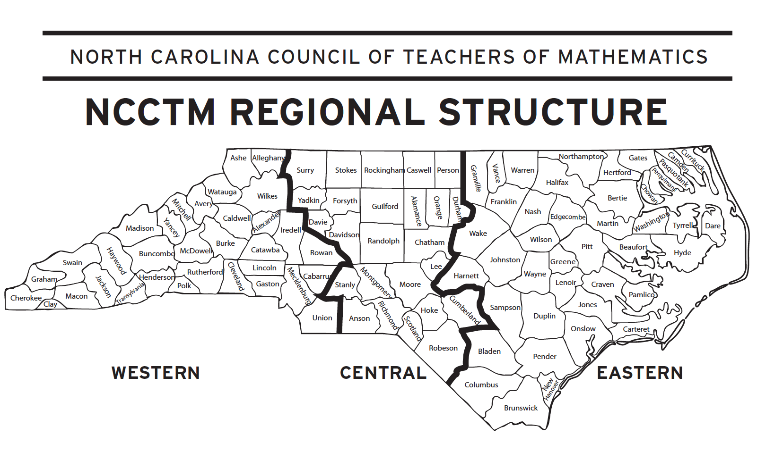
North Carolina Council of Teachers of Mathematics

Mini-Grant Proposal Cover Sheet

PLEASE PRINT CLEARLY OR TYPE

Grant Applicant(s)
Position(s):
School/Institution:
Home Address:

Home Telephone: County:
School Address:

School Telephone: County:
Applicant Email (required)
NCCTM Membership # : NCCTM Region:
Principal Name and Email:
Superintendent Name and Email:
School System
Public Relations name and email:
Title of Project:
Amount Requested
Please have the principal of your school/supervisor of your institution sign below to indicate his/her support and approval of your proposal. This coversheet, with a valid signature, must be scanned and emailed as a separate attachment or by September 30 or January 15 if a second round minigrants is possible. Cursive font is not a valid signature. Proposals without valid signatures will not be considered. Effective 10.26.16, applicants must be full members of NCCTM to apply for a minigrant.

Signature Position Date

Income Tax Notice
Please be aware that NCCTM is required to report all grants of $600 or more to the Internal Revenue Service. In such a case you will receive an IRS Form 1099-MISC from NCCTM. NCCTM has been advised that if you receive one of the NCCTM grants, you must include the grant proceeds in income.

Return this coversheet and direct all questions to:

Joy McCormick, NCCTM Mini-Grant Coordinator
Email: jmccormick@rock.k12.nc.us

